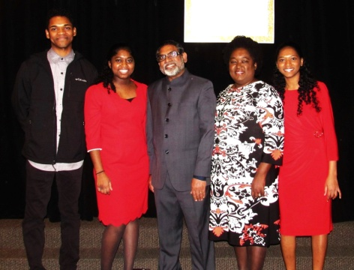**Love & Hope Ministries**

**“Comforting the Distressed”**

**20thAnniversary Celebration**

**A night of thanksgiving and fellowship to celebrate what God has done.**

**&**

**A night of vision casting for the future**

**Date: Friday, March 8, 2024**

**Time: 6:00-8:00 PM**

**Place: New Life Church**

**1244 Thompkins Ln, Virginia Beach, VA 23464**

Indian & Haitian Hors d'oeuvres and dessert will be served.

$15 for Adults and $10 for Children under 13

Invited by: Jabez & Gloria Rapaka

New Life Missionaries to Haiti & India

Contact Information: [loveandhope@juno.com](mailto:loveandhope@juno.com)

757-822-0069/757-839-0874

If you are unable to attend, please prayerfully consider donating to the work of God in Haiti and India: There are several ways to give: 1. Go to our website at

<https://loveandhopeministries.org/donate>

and donate via PayPal or 2. You can give via Cash App: $loveandhopemin or 3. Via Venmo: @loveandhopemin or 4. via Zelle: [loveandhope@juno.com](mailto:loveandhope@juno.com)

Note: If you are able to attend, please sign up by clicking on this link below: <https://www.signupgenius.com/go/10C0B4FADA82CA4F5C34-47245924-love> and pay the registration fee to defray the expenses of the event.